Bryan Guner

Haley Scott

John Kubach

Benito Santos

Lab 1: Basic Electrical measurements and Modeling

8/28 and 9/4

**Abstract:**

The objective of this lab was primarily to allow the students to become comfortable with using a digital multimeter as both an ammeter and voltmeter for basic resistive circuits. Furthermore this lab serves to introduce students to the concepts of accuracy and precision and to demonstrate their impact on electrical measurement. It was also important to give students the opportunity to experience the design process for a simple circuit. Finally, this lab served to introduce the concept of a mathematical model and how it can be used to describe the performance of actual electrical circuits.

**Instruments Used:**

* Digital multimeter
* Multiple resistors of varying resistance
* Voltage regulator
* AA batteries
* Battery holder assembly
* Variable DC power source
* Alligator clips
* Pspice

**Theoretical Basis:**

1. Voltage regulator: A voltage regulator generates a fixed voltage output of preset magnitude that remains constant regardless of changes of input voltage or load conditions. An electronic voltage regulator uses solid state semiconductor devices to smooth out variations in the flow of current. In most cases, they operate as variable resistors, meaning that, resistance decreases when the electrical load is heavy and increases when the load is lighter.
2. Voltmeter: Designed to measure the potential difference between two points on a circuit. It must be placed in parallel (across) the elements being measured. A voltmeter must draw very little current and therefore must have nearly infinite resistance
3. Ammeter: Designed to measure current through a circuit. It must be placed in series (through) the point being measured and must have nearly zero resistance as to avoid affecting the circuit it is measuring.
4. Battery: Batteries use a chemical reaction to produce a voltage between their output terminals. The chemical reaction is used to do work on charge. The basic element is called electrochemical cell.
5. Voltage Divider: Is a resistive circuit composed of resistors placed in series such that any voltage drop can be achieved via specific combinations of different resistance values.

Equations:

1. V=IR
2. P=VI=I^2/R
3. %Error=((|#actual-#theoretical|)/(#theoretical))*100
4. Vout=(Vin*R2 )/(R1 + R2 )

Circuit Diagrams:

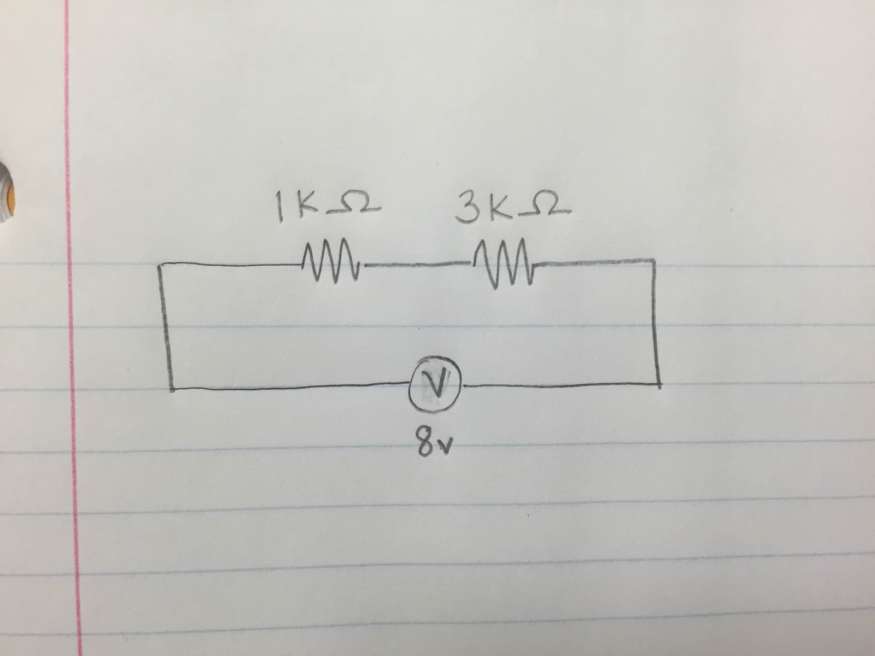

Figure 1: (Voltage divider design from step #3)

 Figure 2: (Pspice circuit model from step #7)

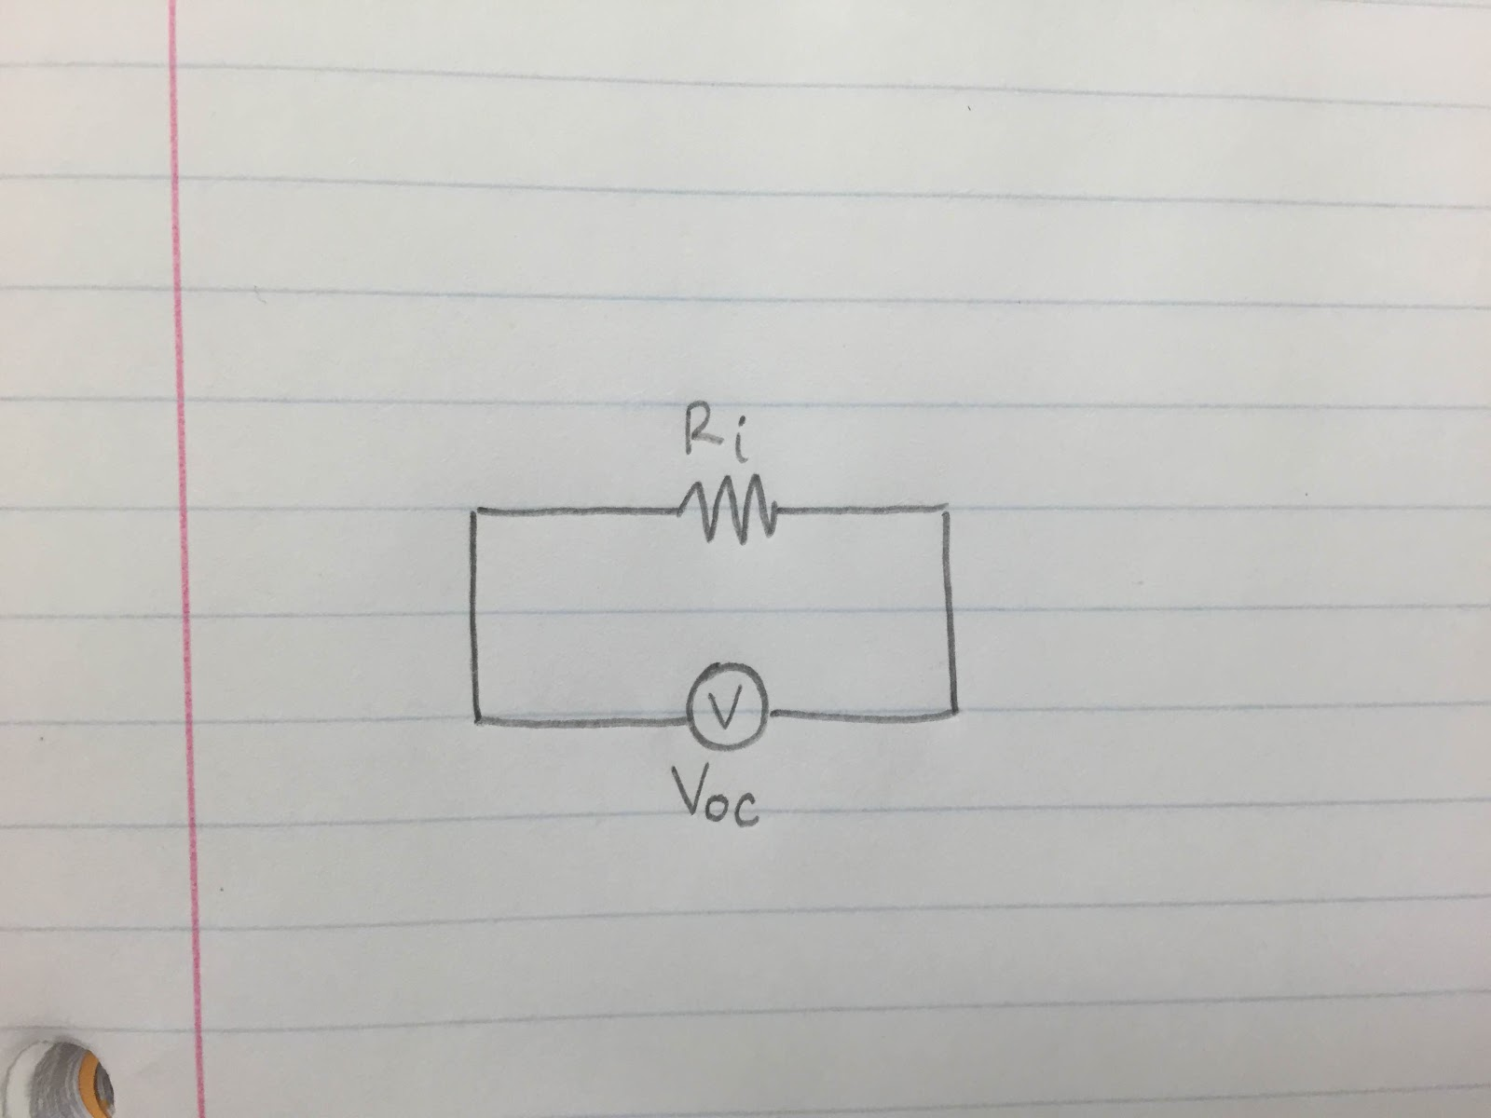

Figure 3: (Basic schematic of a battery with ideal voltage and internal resistance from step#8)

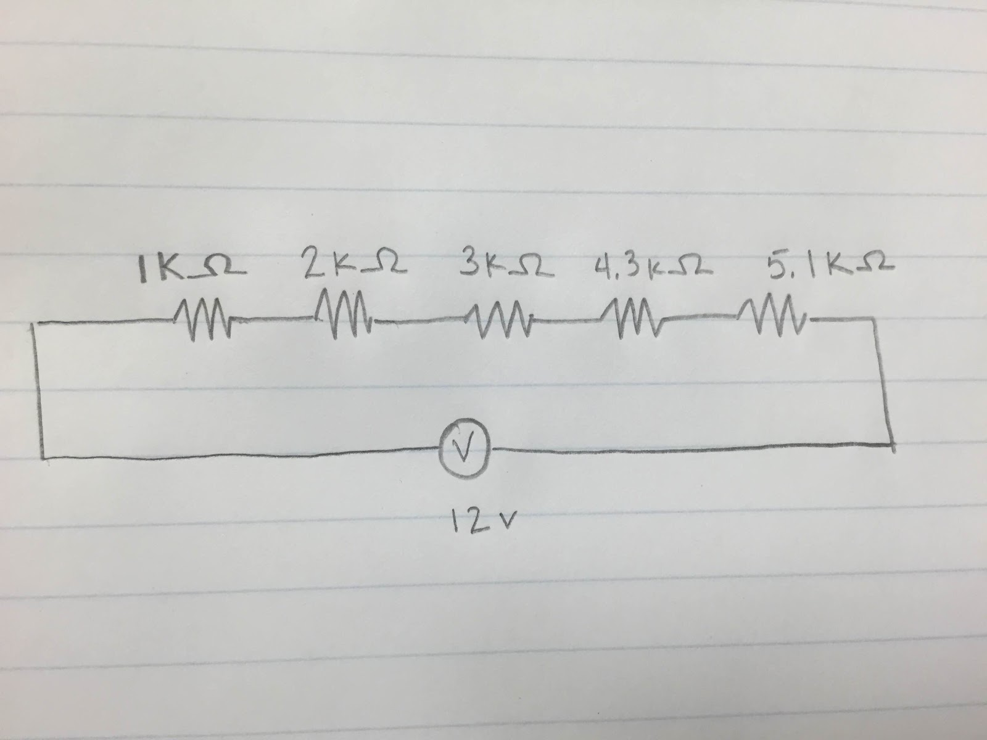

Figure 4: (Real battery with 5 different load resistances from step #12)

References:

For Voltage regulator: [www.Anolog.com](http://www.Anolog.com) & [www.Britannica.com](http://www.Britannica.com)

For Battery: [www.hyperphysics.com](http://www.hyperphysics.com)

**Experimental Measurements:**

Outline:

Procedure

1. Determine the accuracy of the multimeter from the manufacturer’s data. Find overall measurement error when measuring voltage, current, and resistance.
2. Use a voltage regulator to simulate a voltage standard cell. Review specifications of this regulator on the Internet. Connect variable DC power source to voltage regulator, and set power supply to at least two volts greater than the reference voltage.
3. Design a voltage divider to reduce the power supply voltage 2 volts within +/- 10%. Outline a schematic in your lab notebook.
4. Construct voltage divider. Measure resistance of divider. Calculate expected error in output voltage of the divider. Assemble circuit and test voltage divider compare measured voltage with calculated voltage.
5. How does the multimeter affect the circuit?
6. Discuss the measurement of current. How does the multimeter affect the circuit when used as an ammeter.
7. Model your circuit using Pspice, compare the output of the model to the measured results.
8. Create a simple model of the battery by connecting a voltage source in series with a resistor. Draw a schematic diagram of the model in your notebook.
9. Obtain 2 1.5 volt AA sized batteries and special holder from stock room. Measure the open circuit voltage produced by the two batteries in series with your voltmeter.
10. Connect the two batteries in series with a one ohm resistor connected to the battery holder. Quickly measure the resulting voltage and record the values of this voltage and the measured of the one ohm load resistance
11. Calculate the resistance of the battery from the loaded voltage.
12. Test the simple battery model by loading the real battery with five different load resistances and note the resulting voltage. Compare the measured voltage with the voltage predicted by the model.
13. -16. Were voided due time constraints and batteries.

Derivatives from Procedure:

1. Measurement error was not attainable because the manufacturers data on the multimeter was not provided.
2. While the measurement error range for the voltage regulator was not available during time of the lab, we attained a low percent error and therefore presume that it was within the expected error measurement range.
3. N/A
4. The experimental voltage was very near the calculated voltage based on nominal resistor values and measured resistor values.
5. A) The multimeter affects load on the circuit negligibly when used as a volt meter because it has nearly infinite resistance in parallel with the element it measures. B) The effect of a load resistance on our voltage divider would be to further divide the voltage. C) :/
6. The multimeter affects the circuit negligibly when used as a current meter because it has nearly zero resistance in series with the element of the circuit being measured.
7. See figure 2
8. Vsource=5v ,Voltmeter in series =7.355v ; not possible
9. N/A
10. N/A
11. See conlusions.
12. can’t be completed due to time constraints.

Data:

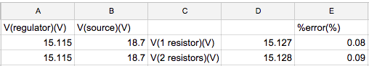

For step #2

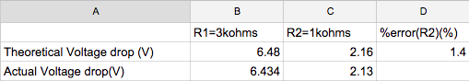

for step #3

**Conclusions:**

There were no general conclusions to draw in this lab because there were no underlying questions to be answered. The purpose of this lab was to get accustomed to basic apparatus and simple circuit design. The only conclusions that can be drawn are specific to individual steps in the procedure and can be referenced in the derivatives of procedure section of this technical report.

Unexpected Results:

In step # 9 we placed a voltmeter in series with a resistive circuit and found a voltage drop significantly greater than the approximate source voltage indicating that there was some flaw in the apparatus or procedure. We replicated this anomaly on other apparatus and ultimately failed to find a tangible explanation for this phenomenon.

In step #11 we were not able to calculate the internal resistance of a battery because we were not able to access batteries. Instead we used a variable voltage source, which could not accurately depict the source voltage because the procedure in step #10 called for a 1ohm resistor which more or less produced a short circuit. Furthermore a variable voltage source means variable internal resistance and so a precise internal resistance proved unattainable given the circumstances.